Prompt
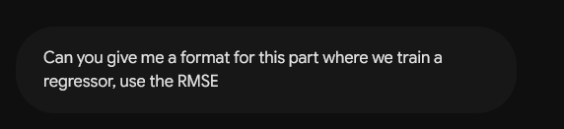

Output

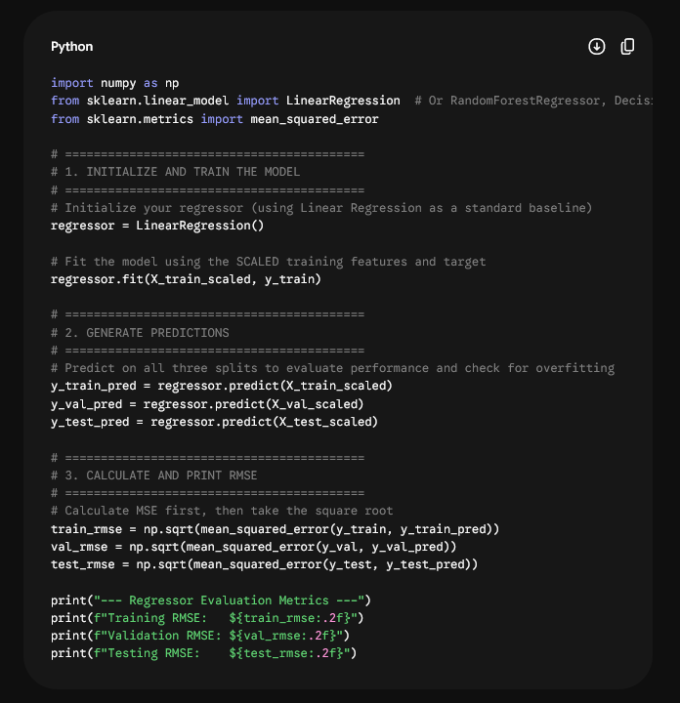

Updated Code:
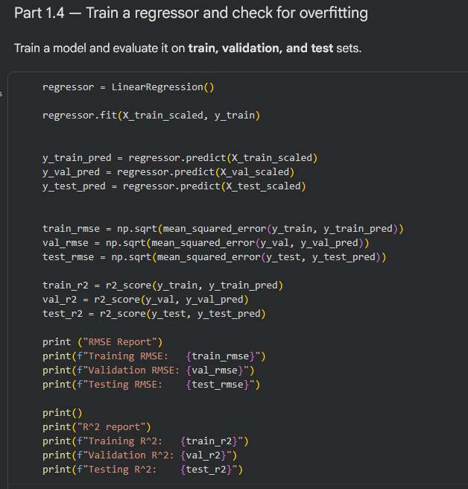

Prompt 2
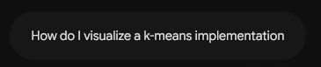

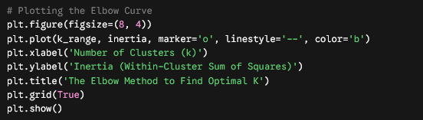
Output:

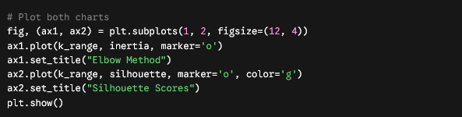
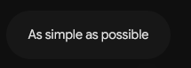
Additional prompt:

Output:

Code (minimum revision):
